**Concepts for Evaluation**

Top three functions to be met:

1. **The device enables rider input towards propulsion**
2. **The device accepts input from Sherpas**
3. **The device absorbs shock**

Overview Table:

|  |  |  |  |
| --- | --- | --- | --- |
| Concept | Function 1 | Function 2 | Function 3 |
| A.1 | * Two independent hand pedals propelling each wheel through a single speed gear train. | * Two extending front rods with grip handles and brake lever. * Rear ergonomic push handles with two handle positions. Two brake levers incorporated (one for each position). | * Two low PSI all-terrain tires with tall sidewalls. * Air cushion under the rider's main cushion seat. |
| A.2 | * Centre hand pedal that connects to solid shaft on either side using chains and sprockets, using a single speed gear train. | * Two extending front rods with grip handles and brake lever. * Rear ergonomic push handles with two handle positions. Two brake levers incorporated (one for each position). | * One low PSI all-terrain tire with tall sidewalls. * Air cushion under the rider's main cushion seat. |
| B.1 | * Lever arm propulsion to rotate chain and sprocket. * Independent left and right wheels allows for turning. | * Rear ergonomic push handles with two handle positions. Two brake levers incorporated (one for each position). | * Regular foam fitted seat. * Spring on castor wheel. |
| B.2 | * Traditional handrim wheel propulsion | * Rear ergonomic push handles with two handle positions. Two brake levers incorporated (one for each position). | * Two low PSI all-terrain tires with tall sidewalls * Regular foam fitted seat. * Spring on castor wheel. |

Concept A.1: “Two-wheel Chariot”

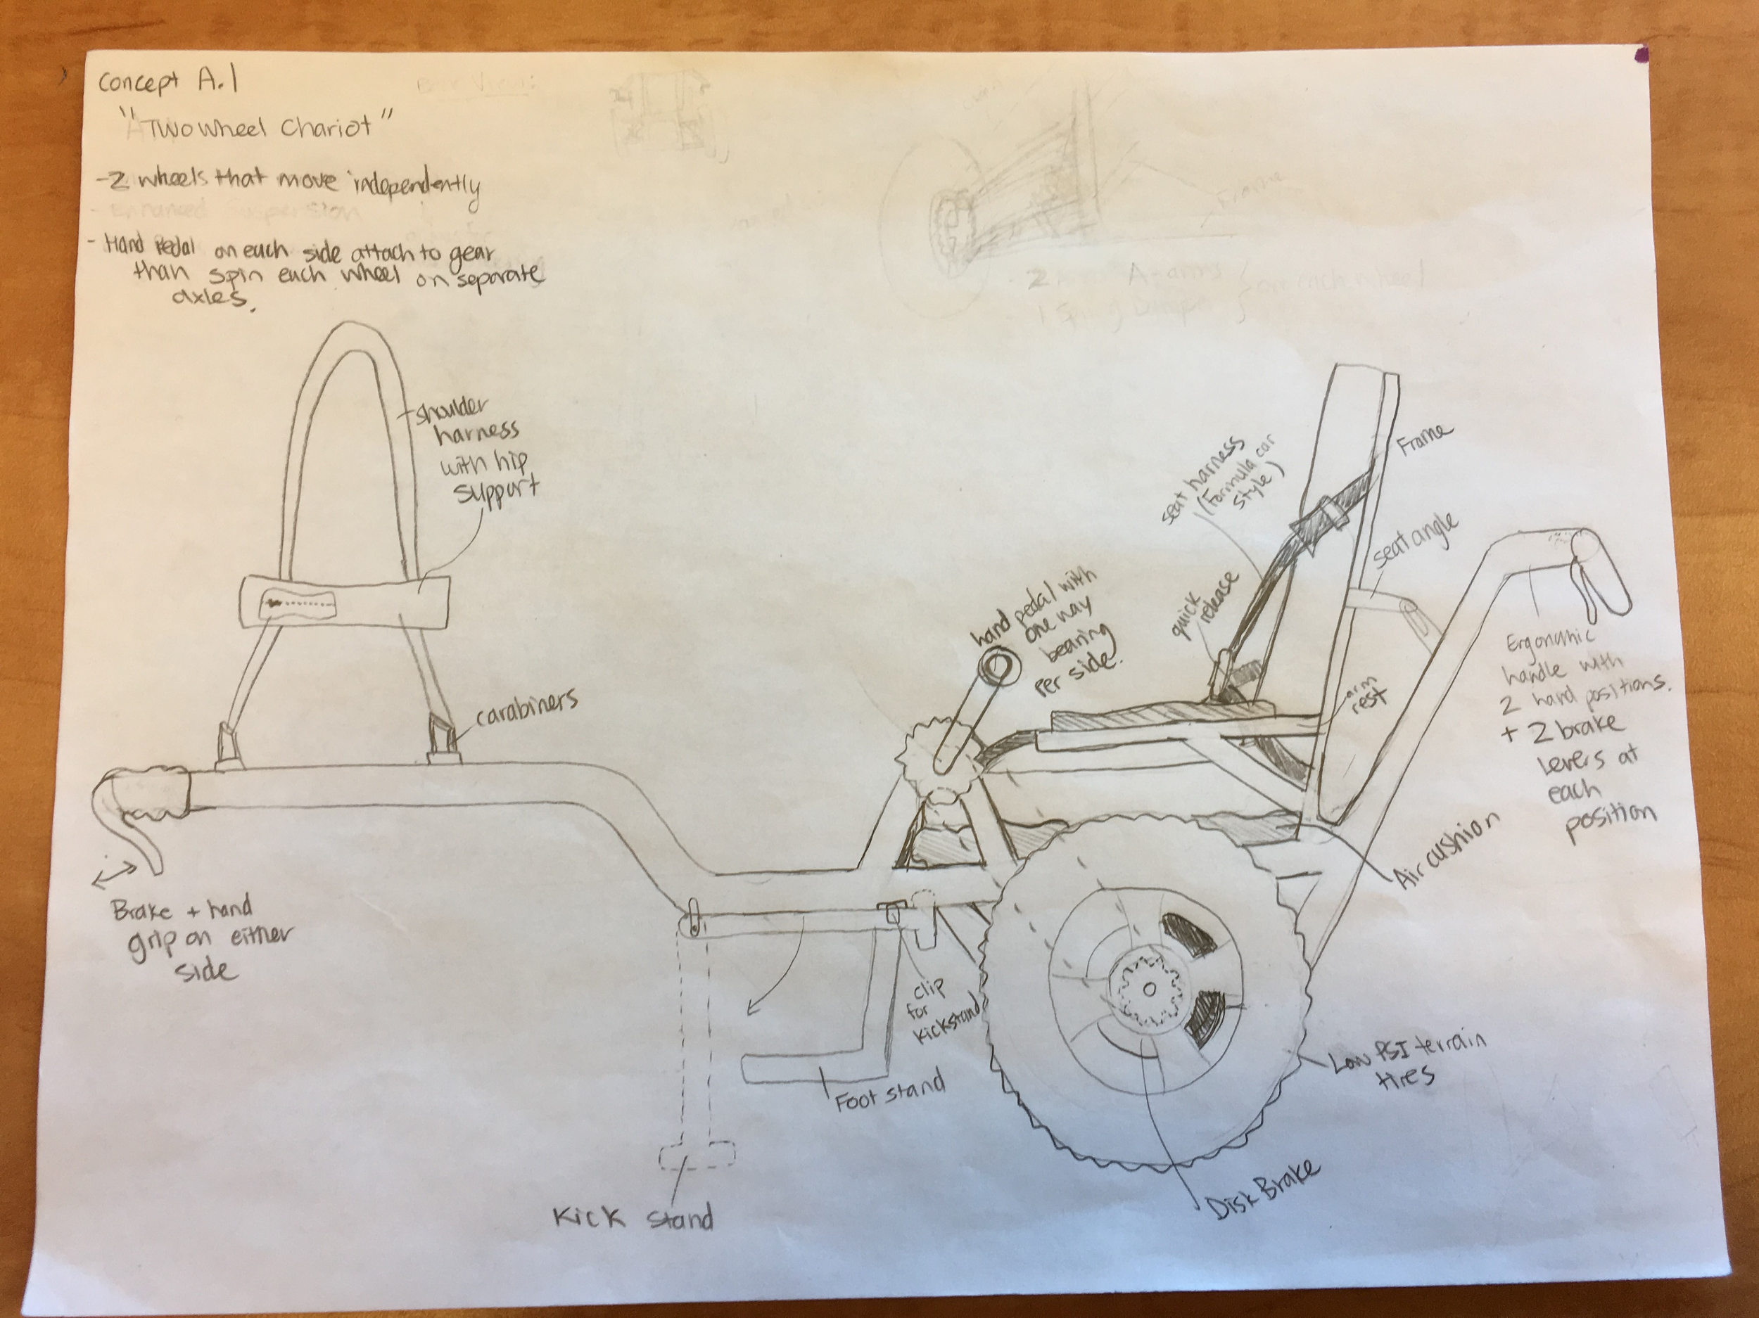

Concept A.2: “One-wheel Chariot”

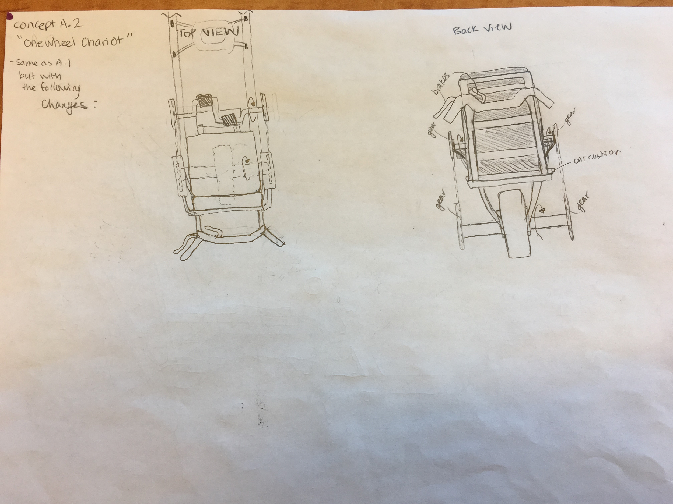

Concept B.1: “Three-wheel Lever Chair”

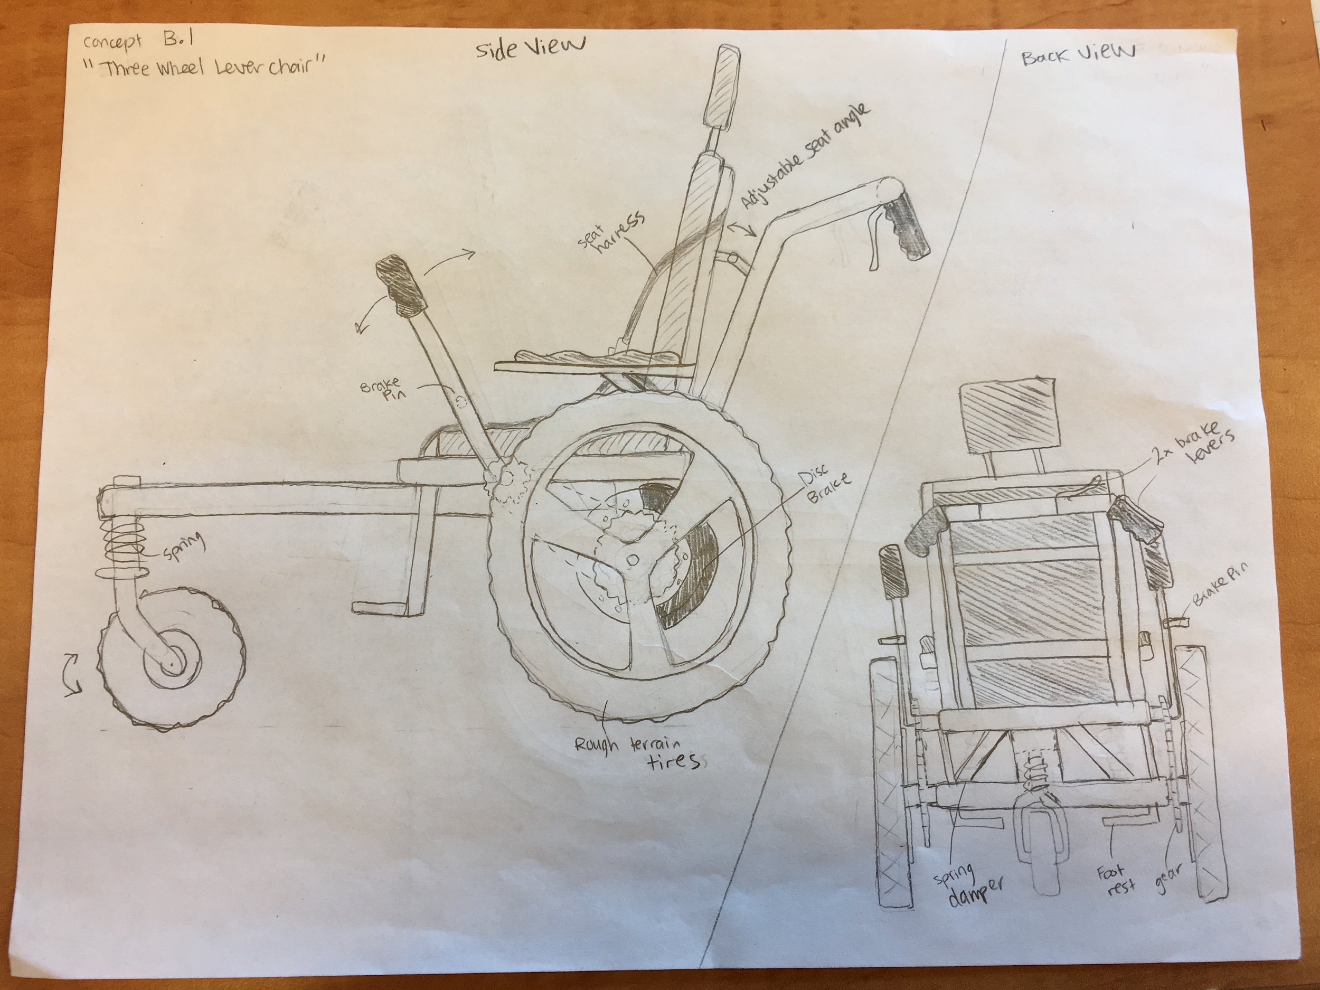

Concept B.2: “Three-wheel Handrim Chair”

